Look carefully at the solar eclipse below. Describe what you can see in the picture. Do not try and explain what you see. Start with the moon.
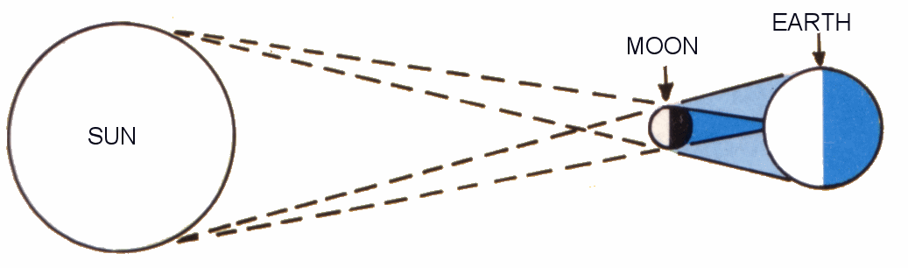

1. The moon is between the Earth and the Sun.

2. ________________________________________________________

____________________________________________________________

3. ________________________________________________________

____________________________________________________________

4. ________________________________________________________

____________________________________________________________

Remember: Imagine the person you are writing for cannot see anything you can see. Don’t miss stuff out and don’t explain!

